

DMU BURIE CAMPASS DEPARTMENT OF COMPUTER SCIENCE

**THE PROJECT TITLE : VEHICLE MANAGEMENT SYSTEM IN BURIE BUS STATION**

NAME OF STUDENT ID

Enkuhane Belayneh ……………………………….048

**Getaneh Addisie………………………………………050**

**Gataneh Shibabaw……………………………………051**

**Getasew Adugnaw………………………………….052**

**Advised By:**

**Mr.Andargie. M**

12/10/2011E.C

List of table

Table 1Unit testing. 11

Table 2. Integrated testing 11

Table 3.System testing 12

**List of figure**

Figure 1: Log In form:- 13

Figure 2: manager page interface 14

Table of Contents

CHAPTER FOUR 1

4 . Implementation 1

4.1 Overview of the programming language used 1

4.2. Algorithms used for login 1

4.3. Sample codes 2

CHAPTER FIVE 11

5. Testing 11

User Interface 1 12

5.3 .Validation testing 14

CHAPTER SIX 15

6. Conclusion and Recommendations 15

6.1 Conclusion 15

6.2Recommendation 15

6.3 Future Enhancement 16

# CHAPTER FOUR

# 4 . Implementation

## 4.1 Overview of the programming language used

* PHP is a popular and widely used programming language which is utilized to build dynamic web applications with MySQL database connections. Because it is user Friendly and Easy to Learn, Cost user Friendly, It’s fast and easy, it accesses everything etc...
* **Back End**
* MySQL software of the data base system and PHP language was used in developing and managing the back end of the system.
* **Front End**
* The user interface had been developed using html, java script, CSS since it easily designing the front end and connected in to database easily.

We use HTML and CSS for prepare user interface.

* We use java script for form validation
* We use MYSQL database for storage of data.

## 4.2. Algorithms used for login

**Login** (**Username, password**):- that pass/checks three arguments for login function.

* If length of username and password==0:- Check that Zero length is not allowed.

Display error message “username and password cannot be empty”.

Stay in the same page and the actor fills the form after he or she knows the field is required.

The system retrieves username and password which the actor submits.

* If username! =username or password! =password or status! =active: - Authentications for the right actor.

Display error message “Invalid username or password or your account is deactivate”.

* If his/her account detail is correct access the required page.

//End of the function login

## 4.3. Sample codes

Coding is the process whereby the physical design specification created by the designers is turned in to working computer code by the programmer. The code is made simple in such a way that another programmer can easily understand and work on that in future

**For register vehicle**

<?php

include("connection.php");

session_start();

if(isset($_SESSION['user_id']))

{

$mail=$_SESSION['user_id'];

} else {

?>

<script>

alert('You Are Not Logged In !! Please Login to access this page');

alert(window.location='login.php');

</script>

<?php

}

?>

<html>

<head>

<meta http-equiv="Content-Type" content="text/html; charset=utf-8" />

<title>Vehicle Management System</title>

<link href="tooplate_style.css" rel="stylesheet" type="text/css" />

<link rel="shortcut icon" HREF="12.jpg" />

<!-- Start WOWSlider.com HEAD section-->

<link rel="stylesheet" type="text/css" href="engine1/style.css" />

<script type="text/javascript" src="engine1/jquery.js"></script>

<!-- End WOWSlider.com HEAD section -->

<SCRIPT language=Javascript>

<!--

function isNumberKey(evt)

{

var charCode = (evt.which) ? evt.which : event.keyCode

if (charCode > 31 && (charCode < 48 || charCode > 57)){

return false;

}

else{

return true;

}

}

//-->

</SCRIPT>

</head>

<body>

<div id="tooplate_wrapper">

<div id="tooplate_header">

<div id="site_title"><h2 id="hheader"style="margin-left:180px;margin-top:40px;font-size:22px;font-family:Cooper Black;"><b><span style="font-size:36px;color:white"> Burie Town Bus Station</span><br/><br/></b>Online Vehicle Management System</h2></div>

</div> <!-- end of forever header -->

<div id="tooplate_menu">

<ul>

<li><a href="manager.php" class="current">Home</a></li>

<li><a href="registervehicle.php">Register Vehicle</a></li>

<li><a href="vehicleinfo.php">View Vehicle info</a></li>

<li><a href="manage_requests.php">Manage Request</a></li>

<li><a href="assign.php">Assign Vehicle</a></li>

<li><a href="fuel.php">Check Fuel Balance</a></li>

<li><a href="#">Generate Report</a>

<ul style="margin-left:10px;padding-right:4px;">

<li><a href="reportuser.php">Report For Users</a></li>

<li><a href="reportvehicle.php">Vehicle Report</a></li>

<li><a href="FuelReport.php">Fuel Information</a></li>

</ul>

</li>

<li><a href="permission.php">Get Exit permission</a></li>

<li><a href="update.php">Update account</a></li>

<li><a href="viewcomment.php">View Comment</a></li>

<li><a href="logout.php">Logout</a></li>

</ul>

</div> <!-- end of tooplate_menu -->

<div id="tooplate_main" class="shadow">

<div id="tooplate_content">

<form name="form1" method="post" action="registervehicle.php">

<fieldset><table align="center"style="color:black">

<legend align =center><h2 align="right" style="color:Blue">Register Vehicle</h2></legend>

<tr>

<td style="padding-top:12px;">Plate Number:</td>

<td style="padding-top:12px;"><input type="text" name="pno" id="pno" size="20" pattern="\d{3,7}"onKeyPress="return isNumeric(event)" required x-moz-errormessage="Please Enter Number Only between 2 and 8 digit ! " title="Please Enter Number Only between 2 and 8 digit !"/></td>

</tr>

<tr>

<td style="padding-top:12px;">Vehicle Type :</td>

<td style="padding-top:12px;"><select name="vtype" required maxlength="8">

<option ></option>

<option value='Nissan patrol'>Nissan patrol</option>

<option value='Toyota PRADO'>Toyota PRADO</option>

<option value='Toyota single cub'>Toyota single cub</option>

<option value='Nissan pick up'>Nissan pick up</option>

<option value='Cacciamali bus'>Cacciamali bus</option>

<option value='Daewoo bus'>Daewoo bus</option>

<option value='Mercedes benz bus'>Mercedes benz bus</option>

<option value='Fiat-mini-bus'>Fiat-mini-bus</option>

<option value='Other-Type'>Other Type</option>

</select></td>

</tr>

<tr>

<td style="padding-top:12px;">Model :</td>

<td style="padding-top:12px;"><select name="model" required maxlength="5">

<option ></option>

<option value='TVTSLEFY61NRA'>TVTSLEFY61NRA</option>

<option value='KUN25L-PRMDHV'>KUN25L-PRMDHV</option>

<option value='HZJ79LTJMRS'>HZJ79LTJMRS</option>

<option value='CVRULCFD22NWN'>CVRULCFD22NWN</option>

<option value='IHZJ105L-GMRS'>IHZJ105L-GMRS</option>

<option value='KB 7TNJNML'>KB 7TNJNML</option>

<option value='BE637JLSH'>BE637JLSH</option>

<option value='BF120'>BF120</option>

<option value='9BM3840883B'>9BM3840883B</option>

<option value='Other-Model'>Other Model</option>

</select></td>

</tr>

<tr>

<td style="padding-top:12px;"> Engine Number:</td>

<td style="padding-top:12px;"><input type="text" name="eno" id="eno" size="20" pattern="\w{2,20}" required x-moz-errormessage="Please Enter engine Number from 2-20 digit ! " title="Please Enter Engine Number From 2-20 digit !"/></td>

</tr>

<tr>

<td style="padding-top:12px;"><font size="4">Owner :</font></td>

<td style="padding-top:12px;"><input type="text"pattern="\D{3,15}" required x-moz-errormessage="Please Enter Only Letter! at least 3 characters required" title="Please Enter Letter at least 3 characters required " name="owner" id="error12"size="20"/></td>

</tr>

<tr>

<td style="padding-top:12px;"> <font size="4">Capacity:<font></td>

<td style="padding-top:12px;"><input type="text" name="cap" id="cap" size="5" pattern="\d{1,2}"onKeyPress="return isNumeric(event)" required x-moz-errormessage="Please Enter Number of Capacity From 1-65 number! " title="Please Enter Number of Capacity From 1-65 number !"/></td>

</tr>

<tr>

<td style="padding-top:12px;"><font size="4">Productive Date:</font></td>

<td style="padding-top:12px;"><input type="date" name="date" title="Enter Id for search " id="date-pick" placeholder ="year-month-date" class="search" autocomplete="off"/></td>

</tr>

<tr>

<td style="padding-top:12px;"><font size="4">Insurance :</font></td>

<td style="padding-top:12px;"><select name="ins" style="width:148px;" required maxlength="5">

<option ></option>

<option value='Insured'>Insured</option>

<option value='Uninsured'>Uninsured</option>

</select></td>

</tr>

<tr> <td></td>

<td style="padding-top:12px;"><input type="submit" name="submit" value="Save" class="button_example" /></td>

</tr>

</table>

</form></fieldset>

<?php

if(isset($_POST['submit']))

{

//geting values

//$username=$_SESSION['user'];

$pno=$_POST['pno'];

$vtype=$_POST['vtype'];

$model=$_POST['model'];

$eno=$_POST['eno'];

$owner=$_POST['owner'];

$cap=$_POST['cap'];

$ins=$_POST['ins'];

$status=1;

$date=$_POST['date'];

$query="SELECT * FROM vehicleregister where Plate_no='$_POST[pno]'";

$resultw=mysql_query($query);

$count=mysql_num_rows($resultw);

if($count==1){

while($row=mysql_fetch_array($resultw)){

$Plate_no=$row[0];

}

if($Plate_no==$_POST['pno']

)

if($Plate_no==$_POST['pno'])

if($Plate_no==$_POST['pno'])

{

echo "<script>alert(' Plate_no is used by another vehicle!');</script>";

echo'<meta content="3;registervehicle.php" http-equiv="refresh" />';

}

}

else

{

if($pno==$pno)

{

$sql="insert into vehicleregister values('$pno','$vtype','$model','$eno','$owner','$cap','$date','$ins','$status')";//

//echo"$insert";//

if (!mysql_query($sql,$conn))

{

echo "<script>alert(' Already Registered!');</script>".mysql_error();

echo' <meta content="6;registervehicle.php" http-equiv="refresh" />';

}

else

{

echo "<script>alert(' Vehicle Register is successfully!');</script>";

echo' <meta content="6;registervehicle.php" http-equiv="refresh" />';

}

}

}

}

?>

# CHAPTER FIVE

## 5. Testing

## 

Testing is a trial experience in which the deliverables of the project are checked with acceptable Standards in the project. We used unit testing, system testing to test the correctness of each Module and the compiled program.

Table 1 .Unit testing.

|  |  |  |
| --- | --- | --- |
| Tested Form | Test Case | Expected Result |
| Login Form | validate user name and password entry as an input from each end users | Display a message when user didn’t fill user name or password and also when there is user name or password error. |
| All other forms | controlling the proper insertion of data | Display a message when user left some text fields, radio buttons, combo boxes or date and time unfilled and insert improper data in to the form try to save. |

**Integrated testing:** - all the modules will be combined together and tested it for its fitness with each other and with the systems functionality. If error occurs in combining them, the module with problem will be identified and recombined.

Table 2. Integrated testing

|  |  |  |
| --- | --- | --- |
| Tested Form | Test Case | Expected Result |
| Login Form | Check the correctness of the form to be displayed after login is succeeded | Display administrator or system members menu |
| Administrator menu | check proper display of selected options to be accessed | Display the selected form from the administrator form as menu |
| Report from | check whether the report will be generated or not | The selected report will be displayed |
| All forms | check the navigation functionality | The form required Will be displayed |

1. **System testing:** - the team member to performs over all functional testing by checking whether it meets the required target or not. Here the system is partially functional and reached its requirement.

Table 3.System testing

|  |  |  |  |
| --- | --- | --- | --- |
| Tested from | Test case | Expected result | Actual result |
| Login form | To validate the proper functionality of login by inserting username and password | To authenticate user | ser will be authenticated and if user is authorized enter to the system else confirm invalidity |
| Search from | To validate the functionality of search form | Search result | If the requested record exist display the result else if it doesn’t exist display the message about the status |
| Report from | To validate the functionality of report form | To generate report | generate the requested report if the request is valid, if request is invalid display message box that describes the invalidity |
| All forms | To validate the functionality of each form | To provide the function required by the form | The form is presented and the required function can operated using the form |

## User Interface 1

1. **Log In form:-**This form found immediately following the home page. Home page appears as the site on which the system is deployed is opened. All user will have their own password. Those forms appeared using password and user name will not accessible by other persons except for those who have privilege.

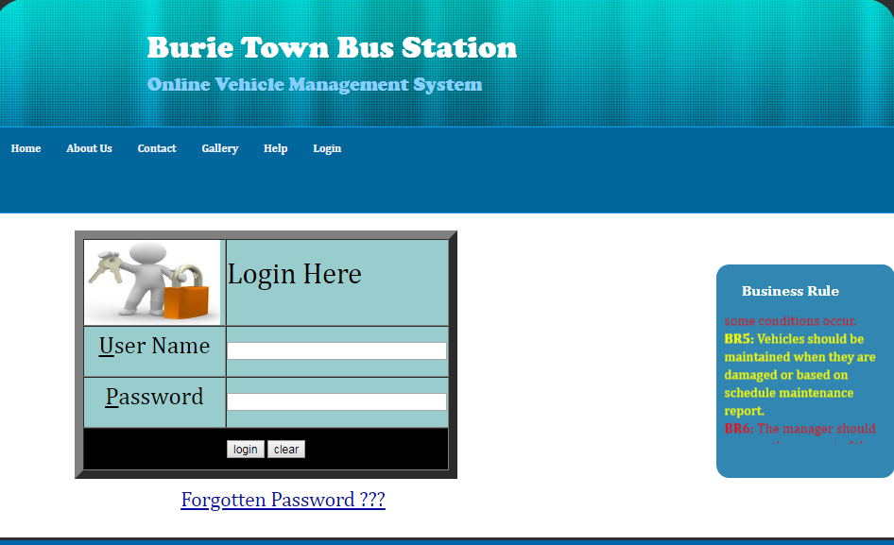

Figure 1: Log In form:-

**B/ manager homepage**

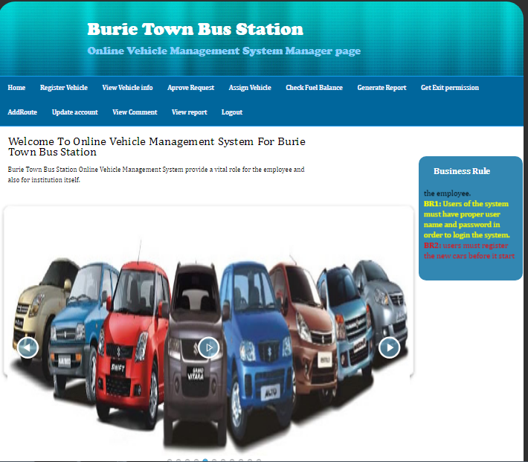

Figure 2.manager page interface

## 5.3 .Validation testing

When we say valid it is to mean that the software functions as it is intended. This is  
tested by giving real data and get real information from the software.

# CHAPTER SIX

# 6. Conclusion and Recommendations

## 6.1 Conclusion

As the scope of this project described we developed the vehicle management system for BURIE bus station by making it more reliable and efficient. The system would register vehicles and perform additional task that would be performed by the system.

So the system would:-

* Minimize the time required to perform task
* Minimize the work load of employees
* Increase customer satisfaction

This document use the object oriented technology called UML (unified modeling language) that enable the user to understand the software easily.

We finally concluded that BURIE bus station vehicle management system would be benefited by the system developed, and accept it cheerfully. During working on this project, we members of the team had learned a lot.

## 6.2Recommendation

The system that we have developed involves web based vehicle management system for  
BURIE bus station. We recommend the following features need to be included in any further revision and extension attempt.

* May used the web based to change in to android or mobile based application.
* Use uninterruptible power supply or UPS if electric power is not available in university.
* Integrate with the traffics system.
* Adding the chatting system.
* Include GPS.
* They done all system in organization are automated
* Update this system to android based system or integrate with android and PHP.

Therefore, others who are interested to develop a new system on vehicle management system for BURIE bus station or other related systems can get some initial idea about the system. By focusing on the limitation and functional areas of the system they can also develop a better vehicle management system that automates all files managed in vehicles management office and other related thin.

## 6.3 Future Enhancement

For the future as the services of the associations becomes increased, this system should be improved by adding functions and using better technologies. So, future works that the project team proposed are:

* Maintaining the system according to the services of the organization after applying and testing the acceptance of the project by the organization
* Connecting the system with other bus station organizations
* Appling better security mechanisms.